|  |  |
| --- | --- |
| Course Name | ITD 2313 – Script Programming |
| Instructor | Michael Schnell |
| Student Name | Samantha Ramsey |
| Due date | 3/19/23 |
| Grade | Put grade earned here |
| Grading Comments | Put instructor comments here |

# Simple Graphics

## Turtle Operations

### Page 209

1. The middle of the page has the draw square function code example block.  Create an example that utilizes the function and grab a screen shot of the results.

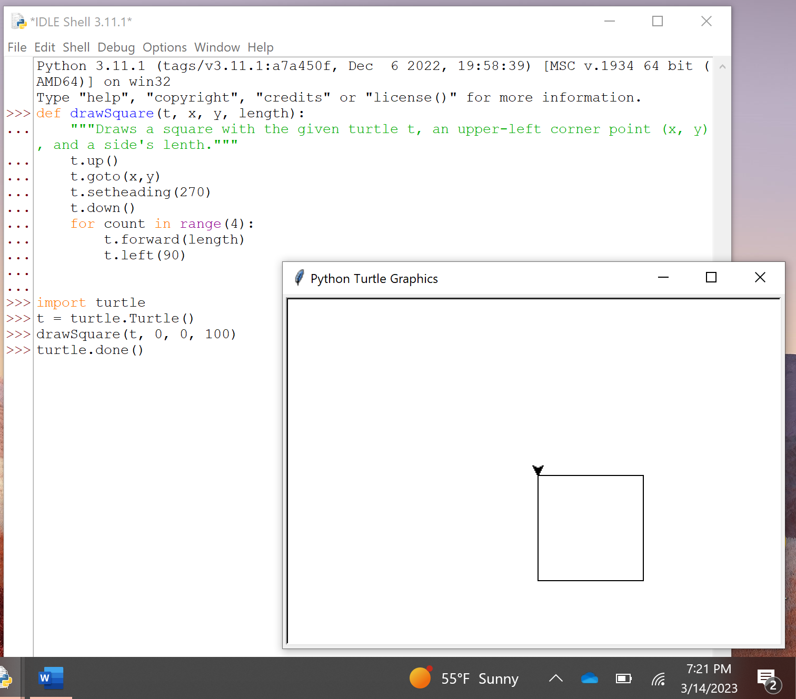

## Object Instantiation and turtle module

### Pages 210-211

1. You will need to create a python program file for this one for best results but you can enter it into the interactive if you want.  On page 210, there are 2 single line code example blocks that set up the turtle object.  Those will need to be entered in before doing the code on page 211.
2. The steps on the middle of the page should build the image at the bottom of the page.  Do the steps and and implement them.
3. You may need to review the pages preceding pages to set up the turtle module.

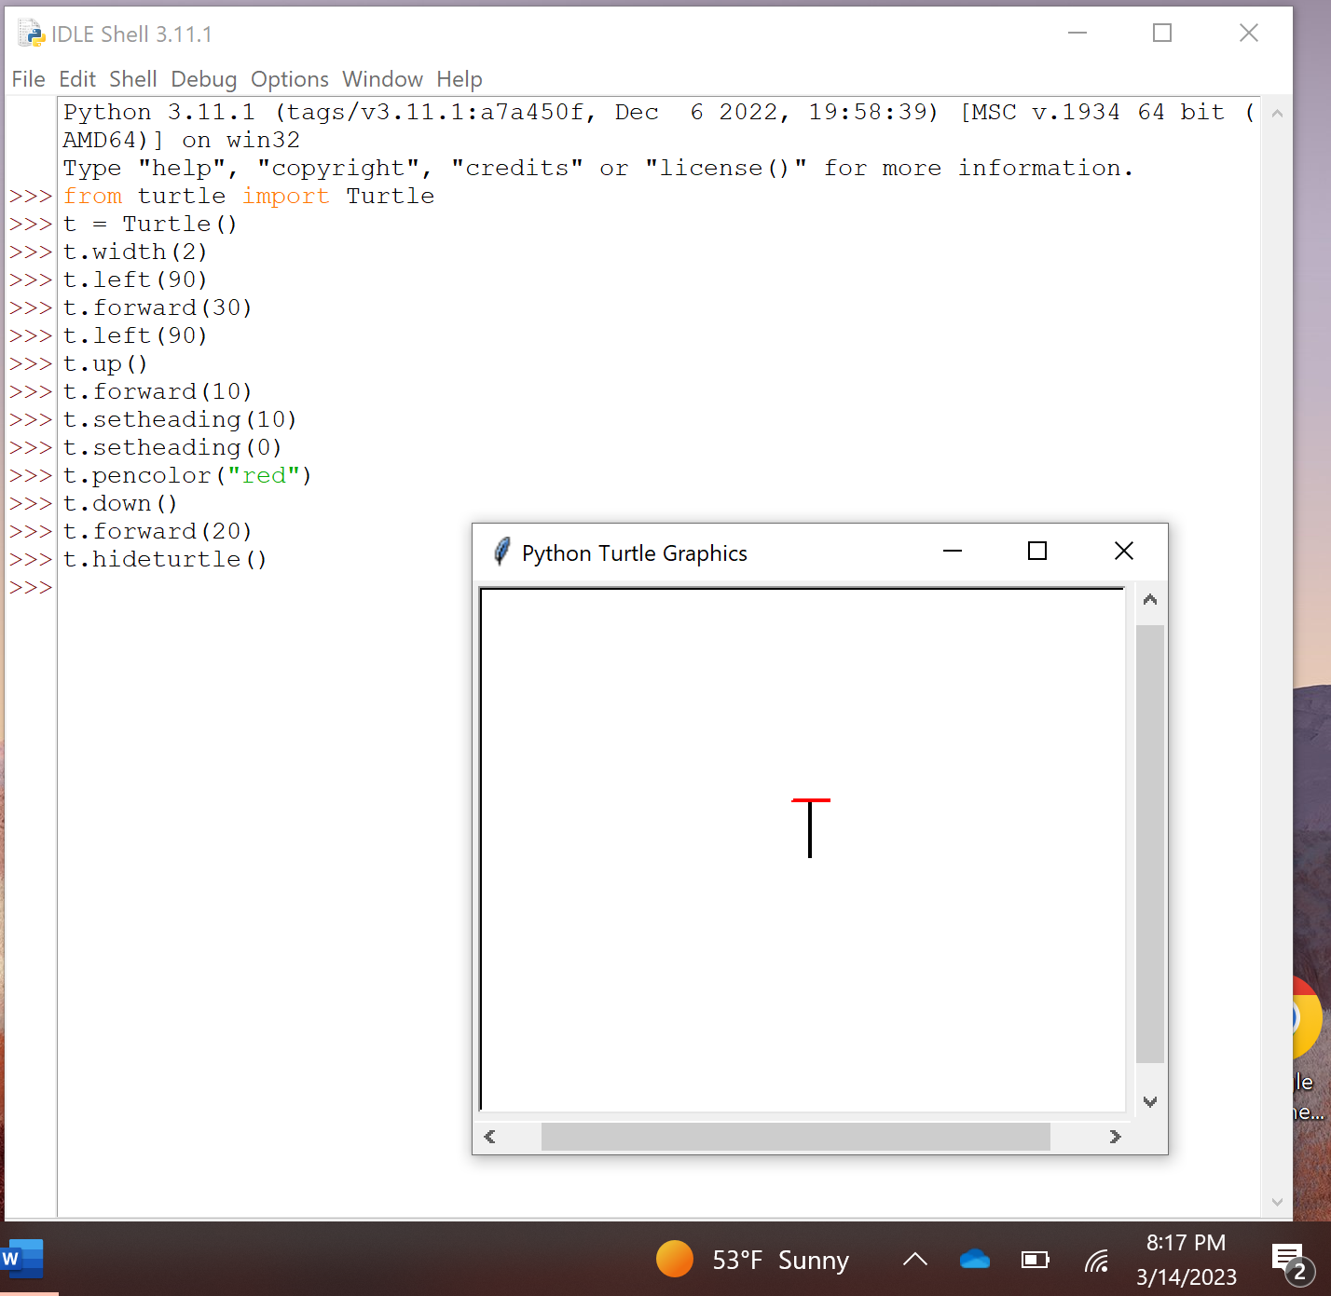

## Drawing two-dimensional object

### Page 212

1. There is a square function and a hexagon function code example blocks on this page.  Create the code that will utilize those functions once you have them entered.  It may be easier to accomplish this using a python program file instead of the interactive mode.
2. Draw the square separately than the hexagon.  One screen shot showing a square drawn.

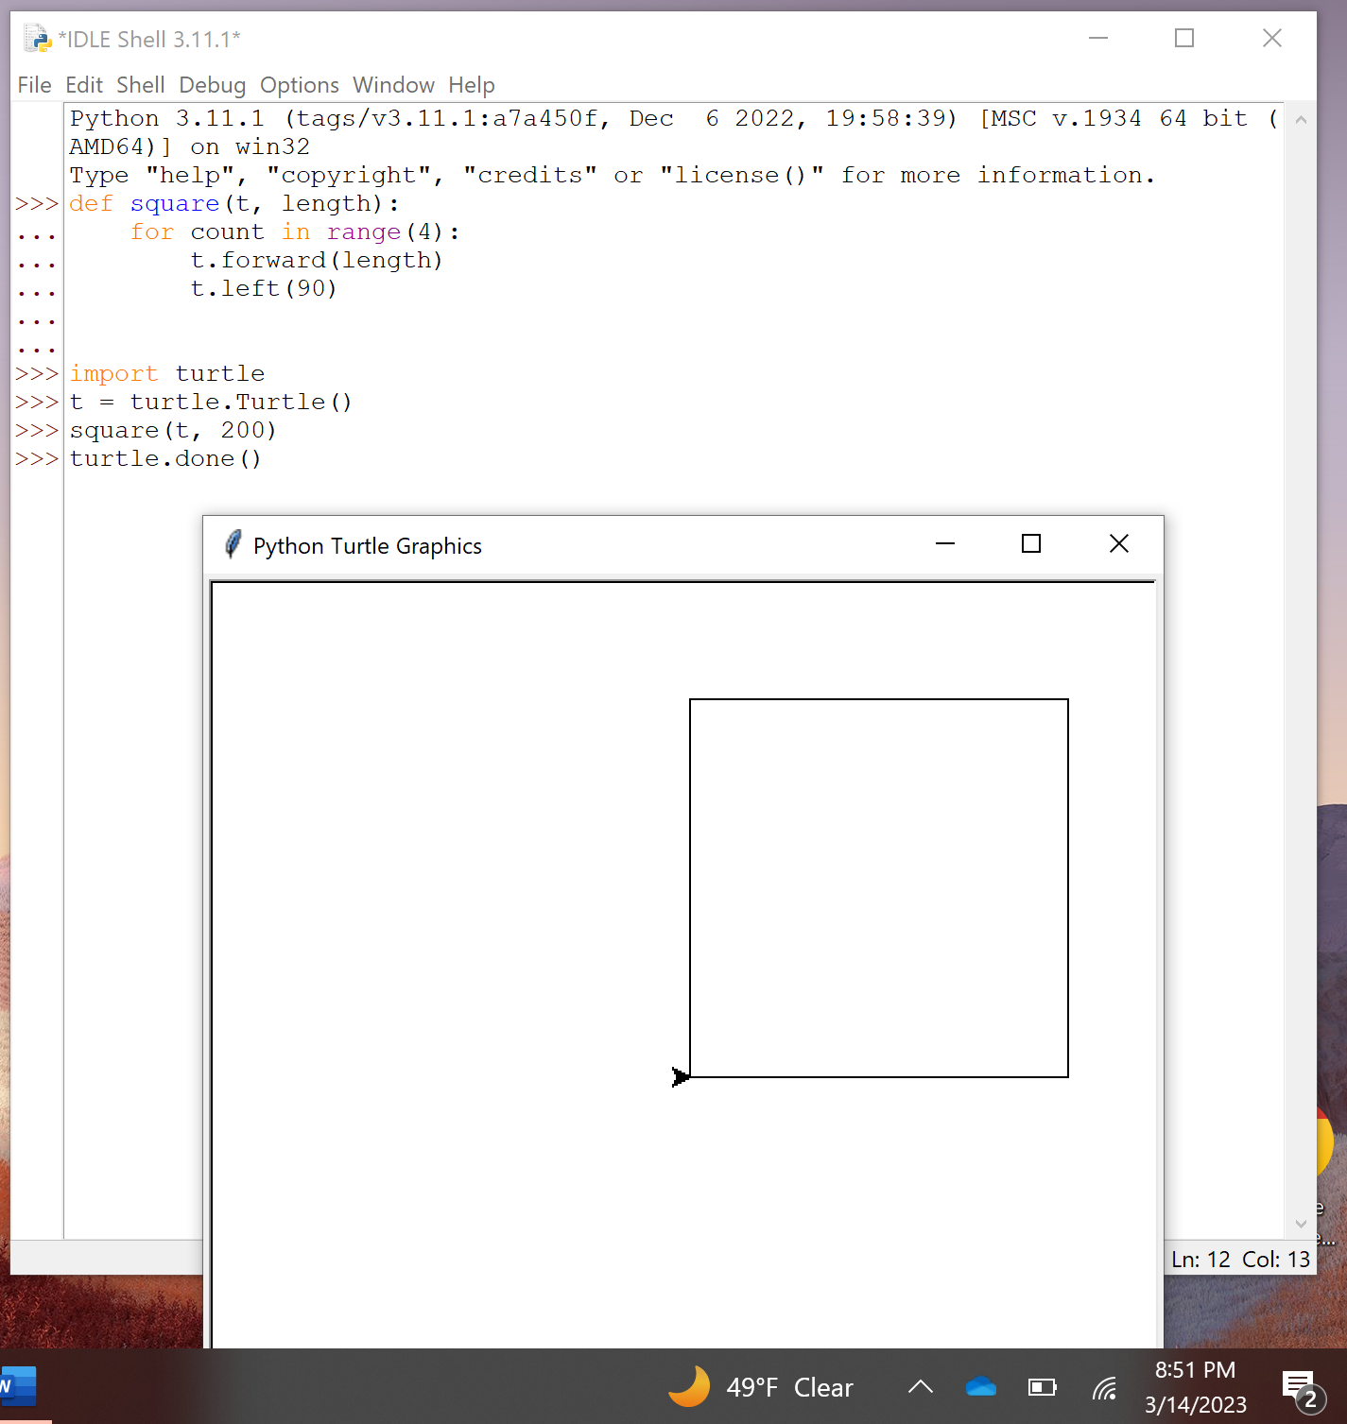

1. The a second screen shot showing the Hexagon being drawn.

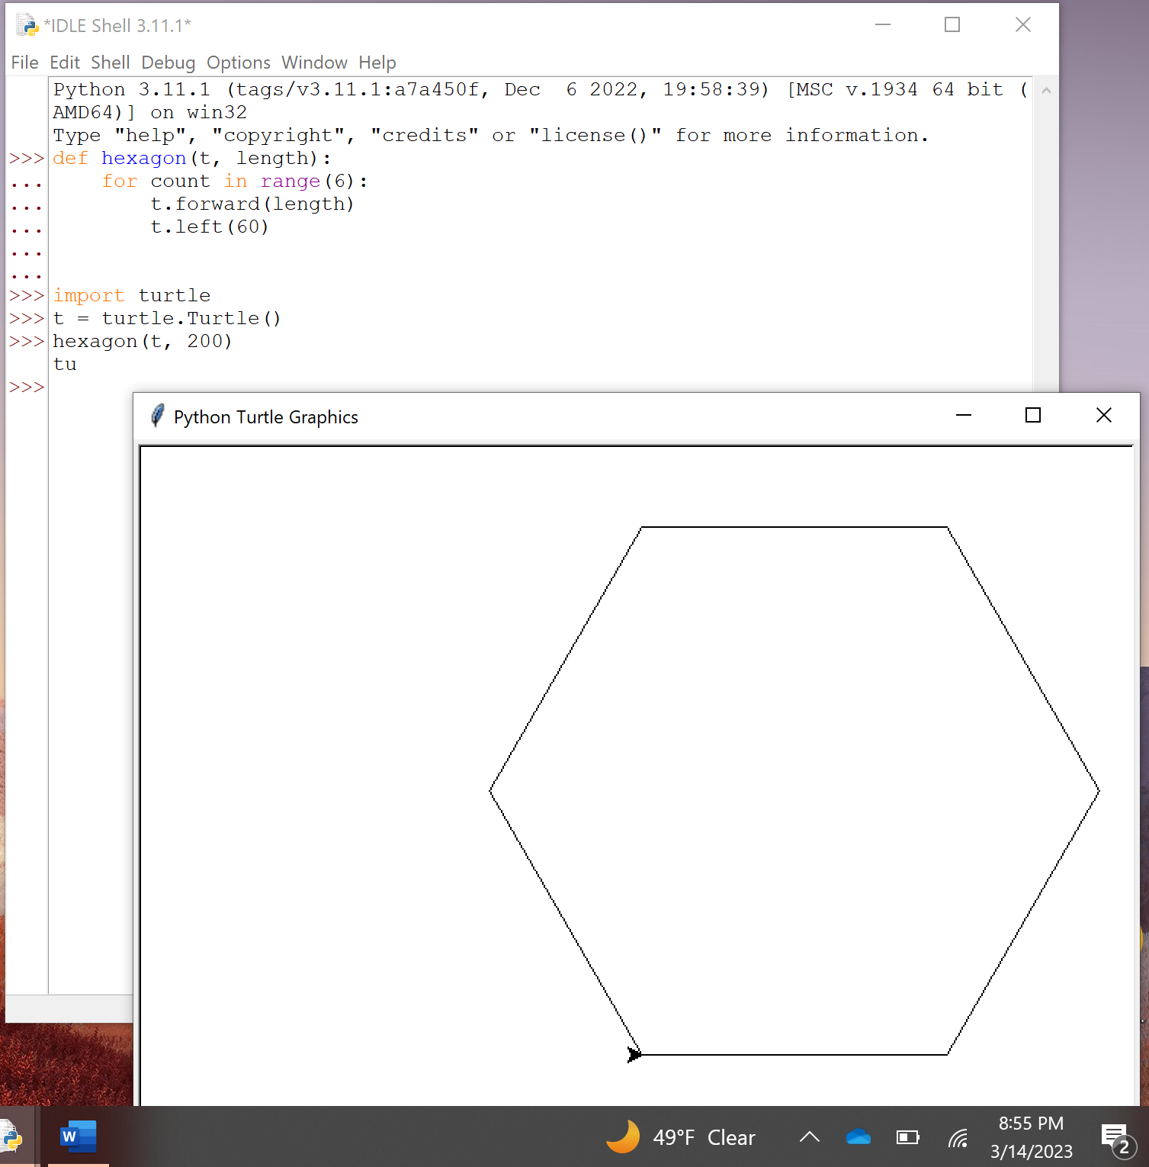

### Page 213

1. Now do the RadialHexagons code and grab the screen shot.

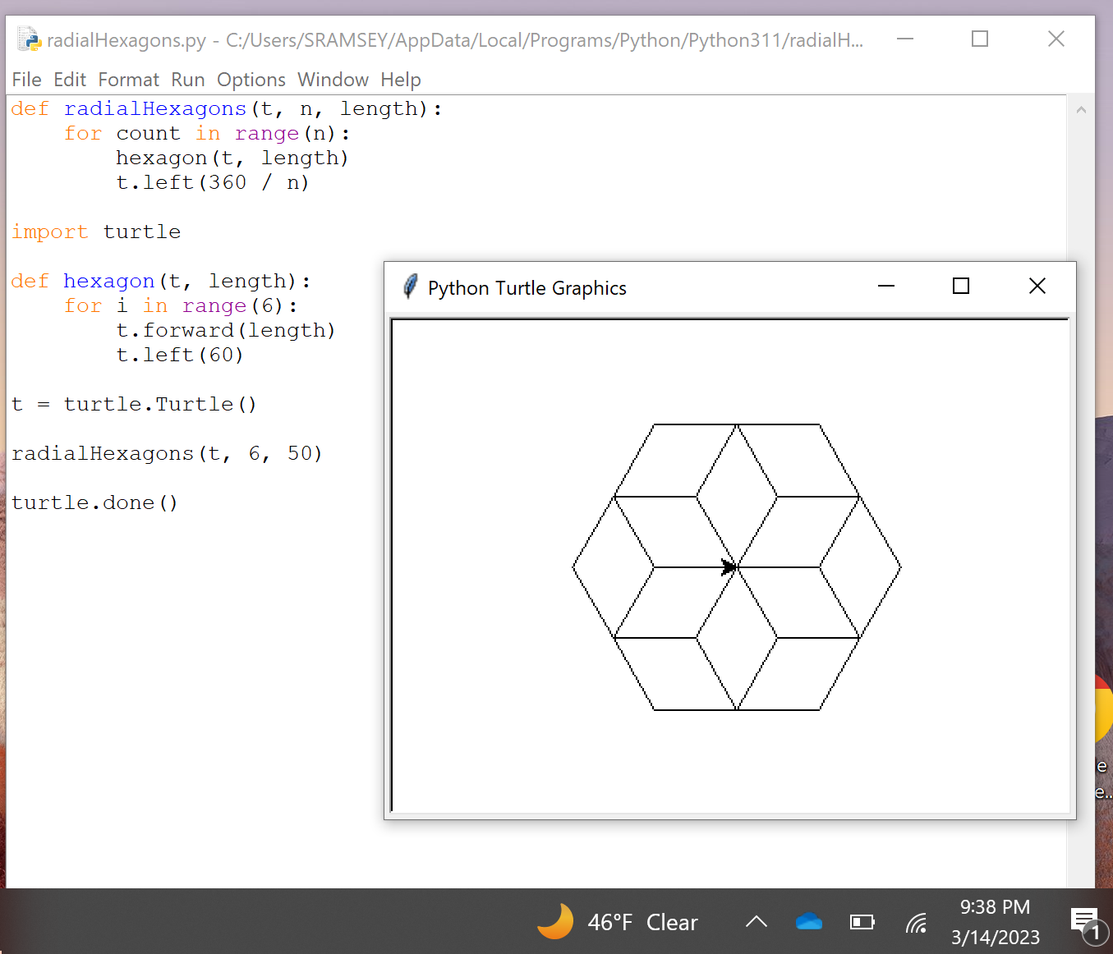

1. Use the function at the top and  then the steps below that for the radial hexagon image

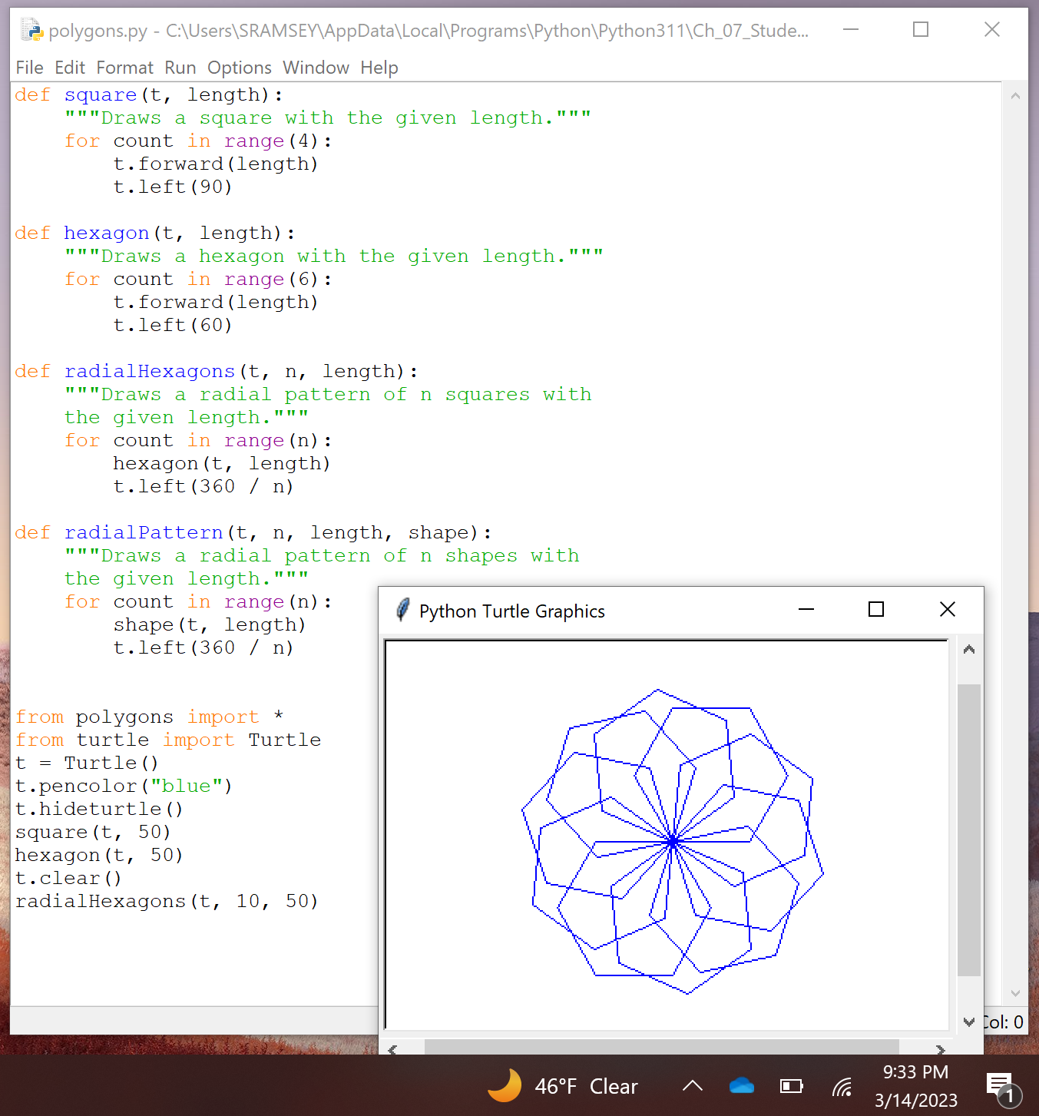

1. Finish up the subsection by doing the radial patterns function and example near the bottom of the page.

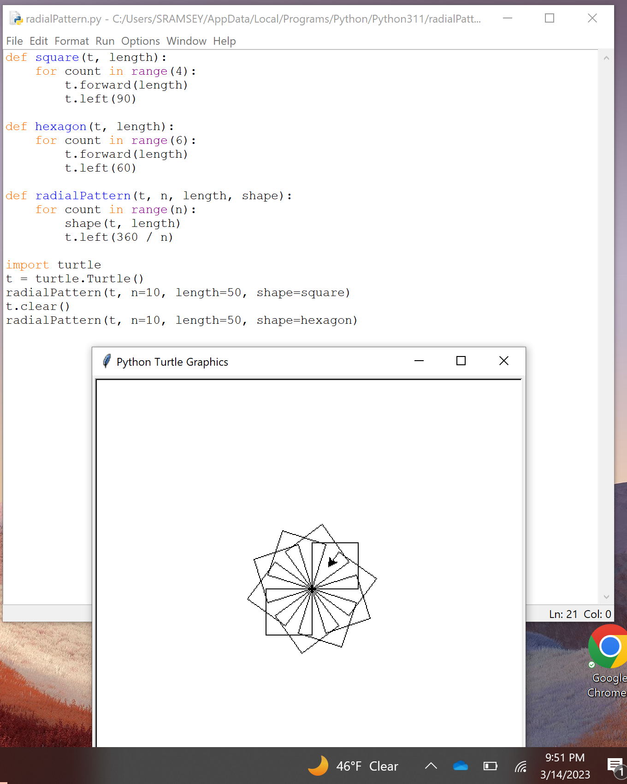

## Examining a Object's Attritbutes

### Pages 214-215

1. On page 214, there are some examples of how to use the attributes and you may not see any results in the turtle screen.

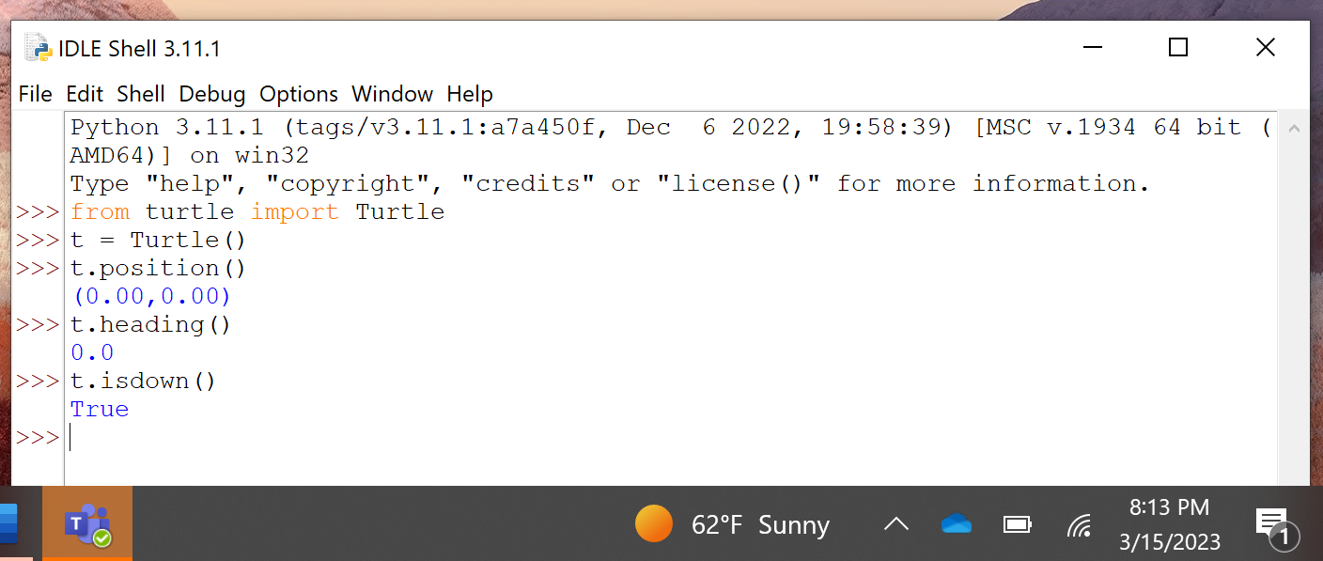

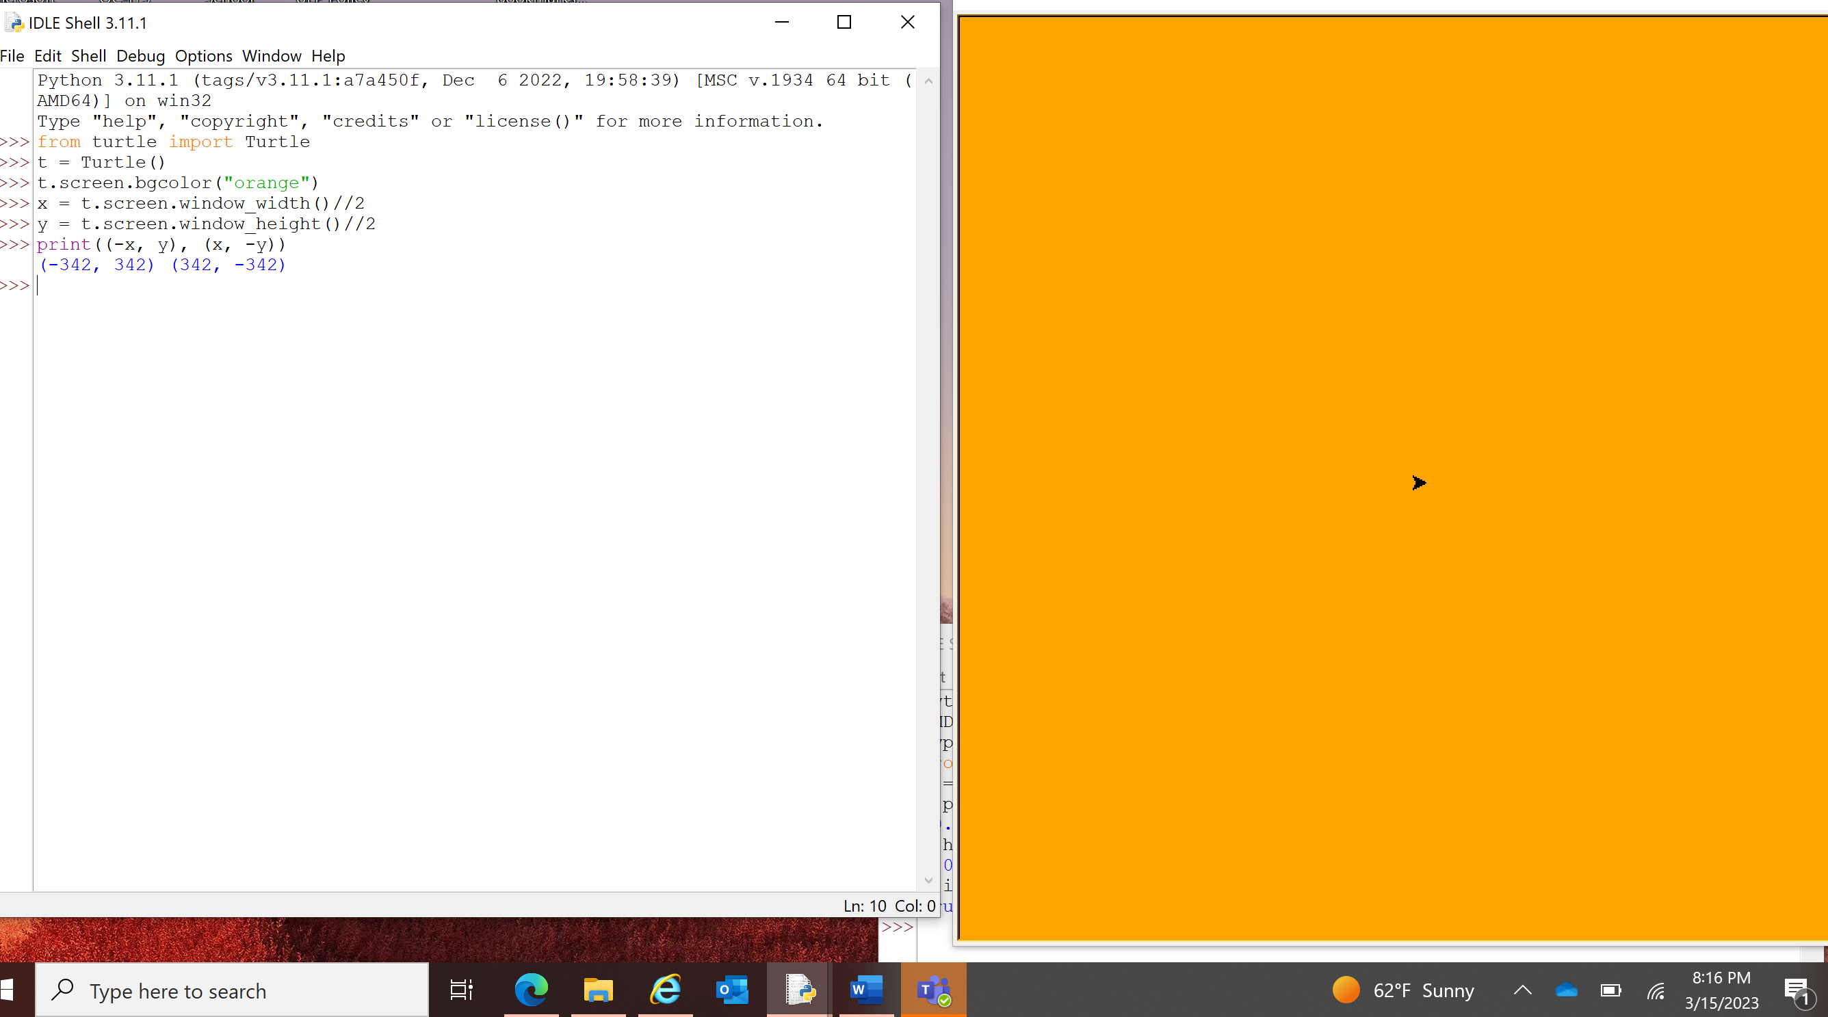

1. For the screen shot, work with the code example block that does the random walk and grab the screen shot of the resulting walk.

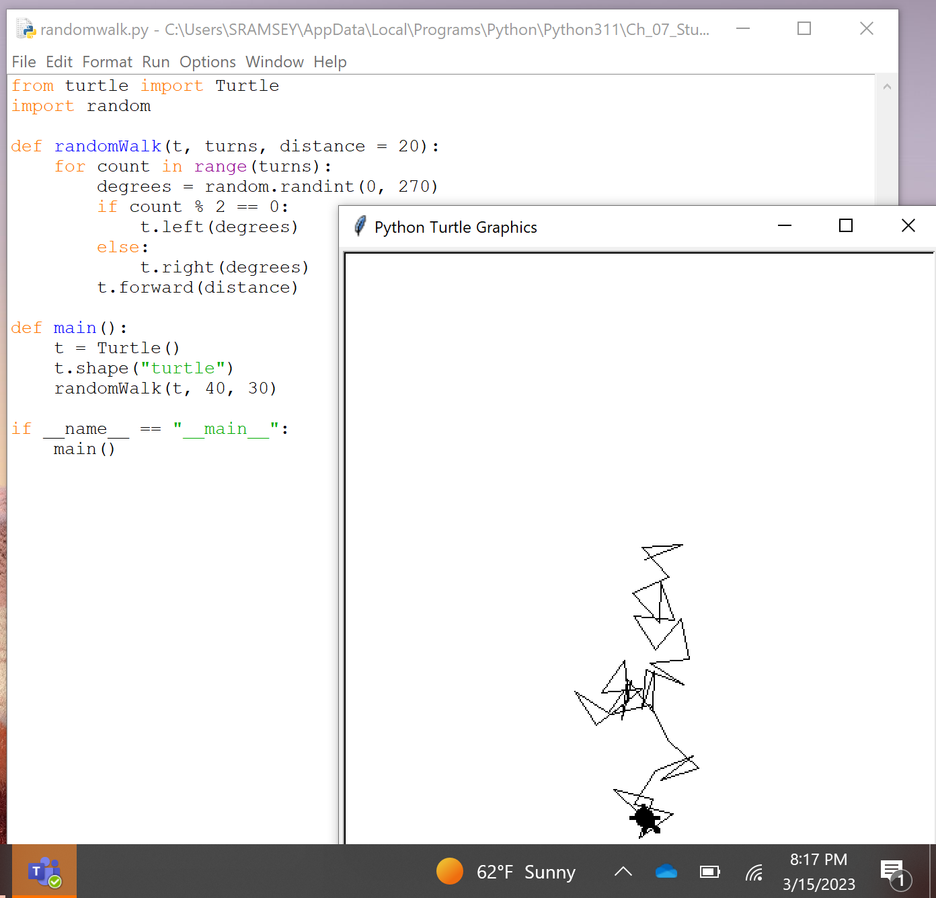

It would benefit you experiment with the code example block on page 217.  It should be part of the download for this chapter.  Experiment with it and makes some changes and observe the results but you do not need to take any screen shots of the results.

The case study will not be captured as part of this assignment either but would benefit you to review the case study.

# Image Processing

## The images module

### Pages 226

1. On the very bottom of the page is the smokey image display code example block

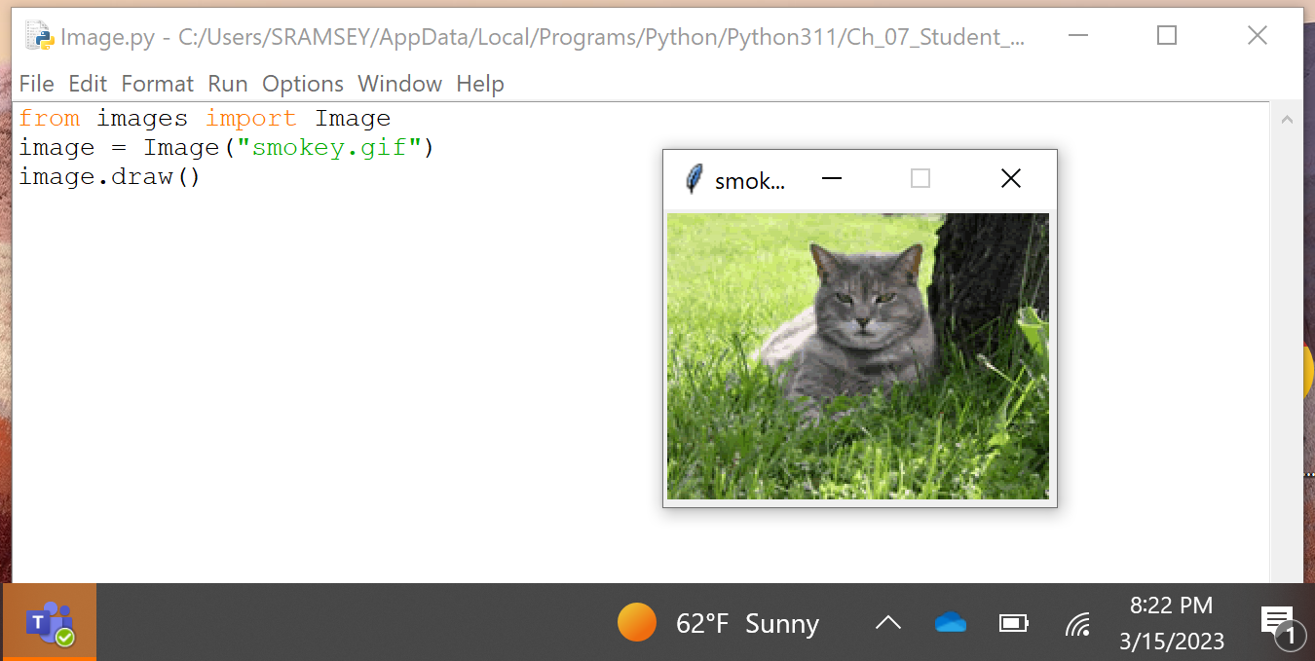

### Page 227

1. The first code example block is just a bit above the 1/2 point and is obtaining width and height info for an image
2. At the 1/2 point is another code example block that prints some of the attribute information
3. The last code example block on this page is about 2/3 down on the page and gets pixel information

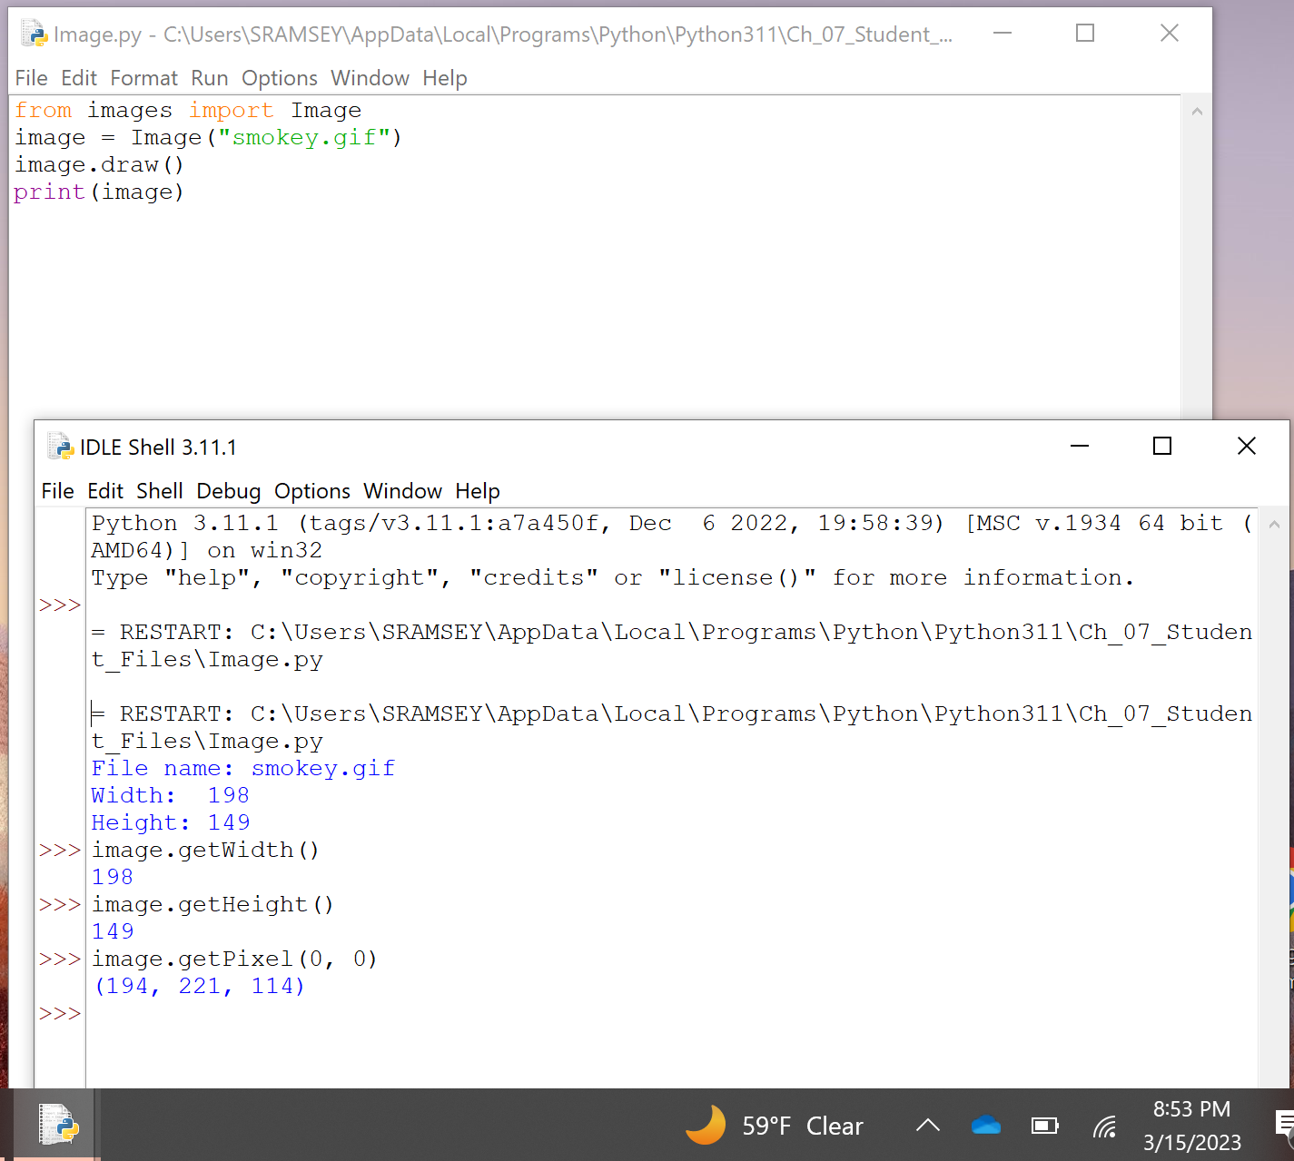

### Page 228

1. At the very top of the page is a small code example block that does a straight line on an image canvas.

## A word on tuples

### Page 230

1. The first code example block on this page gets some r,g,b information from the smokey image followed by displying that information

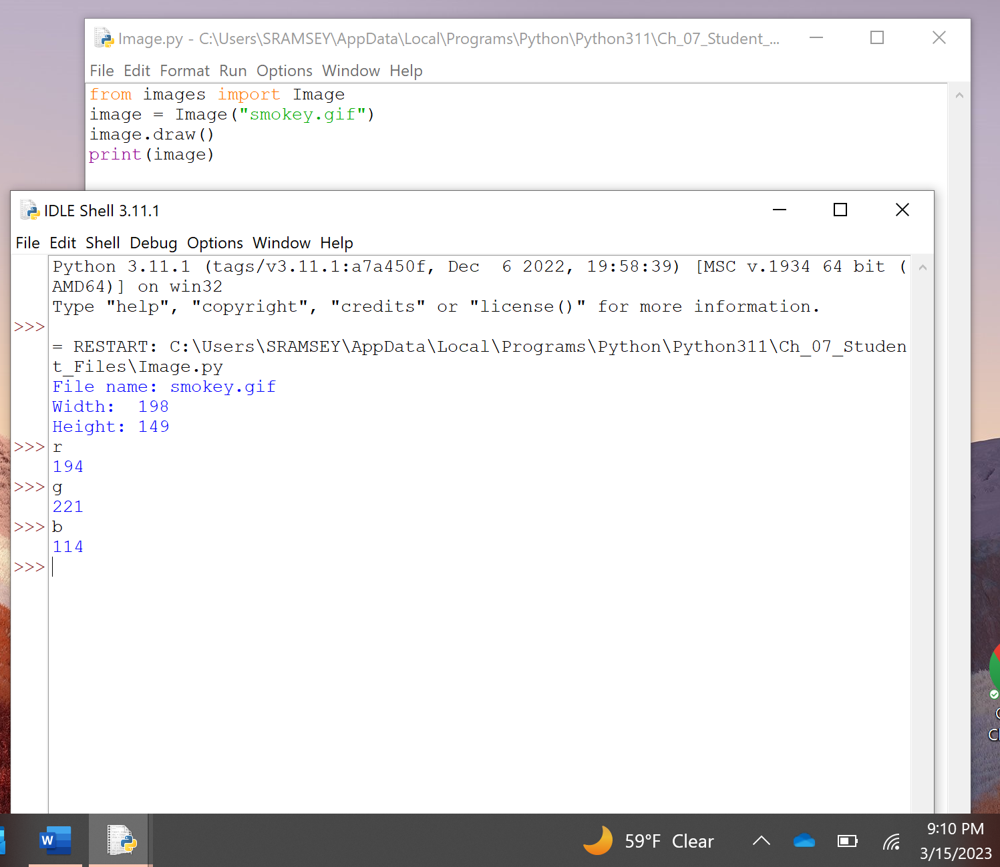

1. The second code example block is setting a specific pixel to a color.
2. The last code example block on this page is the doing the average over 3 numbers.

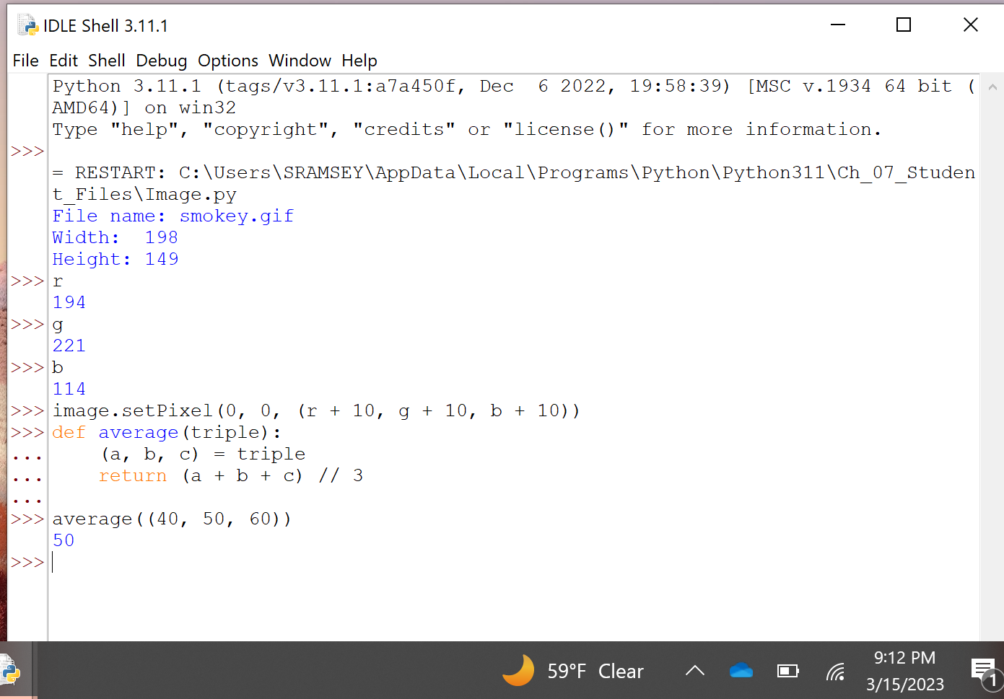

## Copying an Image

### Page 233

1. Going to make a copy of the smokey image with that code at the top of this page.

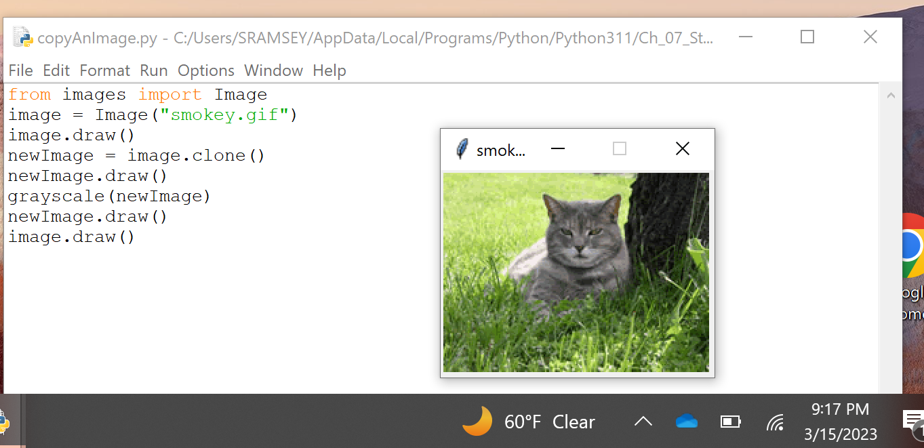

There is a lot of image manipulation in this chapter that you should experiment with yourself.  This includes the blurring of the image and the resizing of the image.